Facts and figures – Rankings
FRANCE ATTRACTIVENESS SURVEY 2022
EY – May 31, 2022

The EY France Attractiveness Survey is a benchmark study of European countries. The 2022 survey confirms the excellent results revealed in March 2022 by Business France in its Annual Report: Foreign investment in France, with France having never attracted so many foreign investment projects. It remains in first place in Europe for hosting job-creating foreign investments.
KEY POINTS
- For the third year in a row, France was the leading recipient of foreign investment in Europe in 2021.
- France welcomed a record number of projects, according to the criteria of the EY survey, up 24%.
- France was ranked first in Europe for receiving industrial activities and R&D.
- 56% of foreign executives interviewed by EY intended to establish or to expand their operations in France in the year to come.
- 46% of foreign executives surveyed about France believed that the French recovery plan was more effective than that in other countries.
- The war in Ukraine has had a significant impact on the perception by foreign decision-makers on the attractiveness of Europe.

In 2021, for the third year in a row, France held onto its position as the leading European economy for foreign investment, with 1,222 investment projects (a historic level) recorded, up 24% versus 2020 (compared with +5% for Europe as a whole). In Europe, the level of foreign investment was 12% lower than the record reached in 2017.

France widened the gap with its main competitors: the United Kingdom posted a modest increase of 2% in its projects, while Germany saw its number of projects fall by 10%.

In 2021, foreign investment created 44,751 jobs in France, a sharp increase and in line with the figures presented in Business France’s Annual Report: Foreign investment in France.

Although the number of jobs per project was lower in France than in Germany or the United Kingdom, the number of projects with more than 100 jobs was equivalent in France and the United Kingdom and significantly higher than that observed in Germany.

In the rankings of French regions, Ile de France (Paris region) kept the lead, ahead of Auvergne-Rhône-Alpes, Grand Est, Hauts de France and Occitanie. All the other regions were on the increase.

French regions occupied four of the top five places in Europe for the establishment or expansion of industrial plants.

London held onto first place as the most attractive city but is losing momentum (34% of executives classified it as the most attractive city, compared with 43% in 2021), while Paris is progressing strongly (28% in 2022, versus 18% in 2021).

France was once again this year the leading European economy for industrial investment, showing a 41% increase in industrial projects.

France also remained in first place for hosting R&D activities, with 61% of foreign investors considering France to be more attractive than other countries in terms of technological factors, while 50% planned to increase their R&D activities in France over the next three years.

The growth of teleworking has had an impact on the service industry, with software and information systems not observing any more new establishments in 2021 than in 2020.

EY’s sector-by-sector analysis confirms the results presented in Business France’s Annual Report: Foreign investment in France. Although the healthcare sector was in slight decline after the record levels of 2020, it remained at a very high level. The same movement can be observed in the United Kingdom or in Germany. With the reconfiguration of supply chains, France is seeing a sharp increase in industrial and logistics projects. The sectors most affected by the healthcare crisis (automotive, aerospace, chemicals, plastics and construction) have returned to a level of investment close to 2019.

Foreign executives confirmed their confidence in European economies and France in particular. Nevertheless, the war in Ukraine has had a significant impact on their perception.

56% of foreign executives surveyed by EY intended to establish or expand their operations in France over the coming year, up from 44% in 2021 and 16% in 2020. However, the war in Ukraine is a new shock that threatens the recovery of foreign investment in Europe: 79% of businesses surveyed before March 1, 2022 planned to invest in Europe during the next year, a proportion which drops to 48% for those surveyed after March 1, 2022.

63% of executives believed that France and Europe will improve their attractiveness within three years. A significant drop in this rate was observed following the start of the Russian-Ukrainian conflict.

46% of executives surveyed believed that the French recovery plan is more effective than that in other countries.

The five development priorities put forward by foreign businesses for France were: support for innovation, reduction of taxation, improvement of the quality of its products, access to skills and adaptation of regulations to technological breakthroughs.

Change in the number of foreign investment projects recorded in France,
the United Kingdom and Germany since 2010

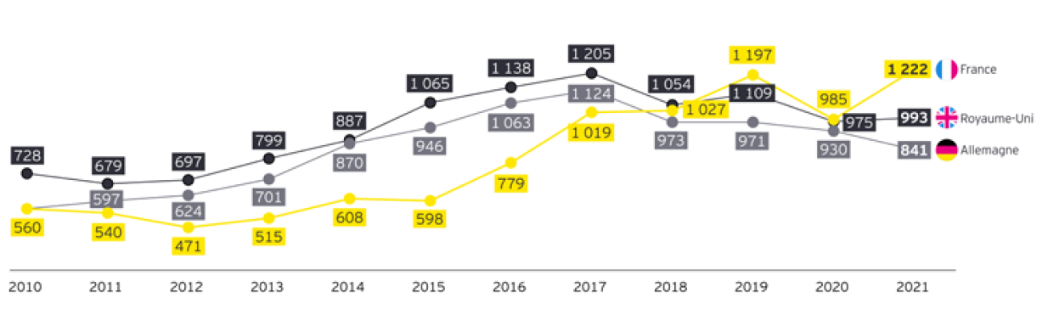
Source: EY European Investment Monitor, 2022

METHODOLOGY
The assessment of the attractiveness of France as an investment location by EY is based on a dual methodology:
- The inventory of job-creating foreign investment projects in Europe, in the context of new investments or site expansions, based on public and firm announcements of investments subject to verification.
- Surveys based on the perceptions and expectations of foreign investors vis-à-vis Europe and France. An initial survey was carried out online during the month of March 2022 among 203 executives of businesses with foreign capital on the perceptions of France’s attractiveness. A second online survey was then carried out between February and April 2022 among 501 European executives on the perception and expectations of economic decision-makers in the face of the Covid-19 crisis.
Unlike the Annual Report: Foreign Investment in France produced by Business France, the EY France Attractiveness Survey does not take into account takeover projects. EY figures do not list investments related to retail outlets of goods or services and do not project jobs created beyond the year studied.
For further information, please visit: https://www.ey.com/en_gl

Business France participates in the expansion and international success of businesses, whether French or foreign, by supporting them from the beginning to the completion of their projects. https://www.businessfrance.fr/en/home

